All on 4 Dental Implants Sydney (H1) REMOVE THIS FROM THE MAIN PIC
Title tag: All on 4 Dental Implants & All on X Sydney | Cost From $18k/Arch
Meta description: All on 4 dental implants cost in Sydney from $18,000 per arch. Also known as All on X or full mouth dental implants. 25+ years’ experience.

All on 4 Dental Implants & All on X in Sydney (H1)
Full Arch and Full Mouth Fixed Teeth, Tailored to Your Anatomy, From $18,000 Per Arch.
All on 4 dental implants replace a full arch of missing or failing teeth with fixed, natural looking teeth that stay in place. No plates, no adhesives, no slipping.
Also known as All on X, full arch or full mouth dental implants, the treatment uses a tailored number of implants, most often four to six, to support your new smile.
Located in the Sydney CBD and easy to reach from across Sydney, Smile Concepts plans every full arch case around your own bone and bite. Our dentists each have over 25 years of experience, and treatment is priced per arch, not per implant.
Whether you are currently wearing dentures, have multiple failing teeth, or have been told your treatment options are limited, the first step is understanding what may be possible for your individual situation.

Real All on 4 Results (H2)
These are real patients treated at Smile Concepts. Every case is different. Results depend on your individual circumstances, and all surgical procedures carry risks.
Warning: The before and after images shown are of real patients of our clinic. They are for illustrative purposes only and do not represent results all patients can expect. Individual results vary.

General Information

What are All on 4 Dental Implants (full arch)? (H2)
All on 4 is a full-arch treatment in which a complete fixed bridge of replacement teeth is supported by a small number of dental implants, most commonly four, and up to six when your anatomy calls for it. It is designed for patients missing all or most of their upper or lower teeth, and it removes the need to place an individual implant for every missing tooth.
The two rear implants may or may not be placed at an angle of up to 45 degrees. This is not just a technical detail. Sometimes, angling the rear implants lets them reach denser bone further forward in the jaw, which is why most patients can avoid the bone grafting traditional full-arch implant approaches often require. Less surgery, less recovery time, and, in most cases, a same-day temporary set of teeth, so you never go without a smile while things heal.
Same-day teeth also depend on adequate implant stability. [1–3]

The final bridge is fixed permanently to the implants. It does not come out at night. It does not need adhesive. It functions much more like your natural teeth than any removable denture can.
The bridge stays in place for daily use and is removed by a clinician when needed. It still requires daily cleaning and professional maintenance.

All on 4 vs All on X: what do these names actually mean? (H2)
If you've been researching fixed teeth, you've probably seen both “All on 4” and “All on X” and wondered whether they are different treatments. They're not. They are two names for the same thing: a full arch of fixed teeth supported by dental implants, so you never take them out.
“All on 4” is simply the best-known name for this treatment. It began as a treatment concept where a full arch is supported on four implants. “All on X” is the umbrella term the profession uses, where “X” stands for the number of implants, because the right number varies for every patient. How we decide that number, and why it never changes your price, is explained further down this page.
All on 4® is a registered trademark and treatment concept of Nobel Biocare. Smile Concepts is an independent practice and plans each full arch case using the implant system best suited to your case, which may include Neoss, DIO, Nobel Biocare, Straumann, NeoDent, Southern Implants or other leading implant systems.

Who is suitable for All on 4 or All on X Implants? (H2)
Suitability for All on 4 at Smile Concepts is always confirmed with a clinical assessment and a 3D CBCT scan at our Sydney CBD practice. As a starting point, it may be worth exploring if any of the following sounds familiar:
- You have lost most or all of your teeth
- Your dentures feel loose when you eat or speak
- Several remaining teeth are failing or beyond repair
- You want a fixed solution that stays in place permanently
- You have experienced bone loss after tooth loss
- You want to understand your long-term options properly

We always determine suitability through a proper clinical assessment. We look at your bone volume, oral health, and medical history before recommending anything. If all on 4 is not the right fit, we will tell you and explain what alternatives exist.

Why Choose All on Four Dental Implants at Smile Concepts in Sydney? (H2)
The all on four treatment concept is all about restoring everyday comfort and function. It's a smarter, simpler way to get a full, beautiful smile and here's why so many people at Smile Concepts in Sydney are choosing it.

Over 25 Years Experienced Team looking after you
If you want highly experienced dental surgeons to genuinely care for you, you've come to the right place.

Permanent Teeth
Say goodbye to dentures that slip and shift. All on 4 gives you a fixed, stable set of teeth that stays put when you eat or talk.

Natural Look and Feel

Fixed implant-supported teeth offer greater stability and chewing confidence than removable dentures. They look, feel and work like your own real teeth. Appearance and function vary between individuals.

One Price, Tailored Support
Whether your plan calls for four, five or six implants, your price per arch stays the same. You get the most stable solution for your anatomy at one clear price.
Results vary, and this treatment isn't suitable for everyone. We assess every case individually before making any recommendation.

All on 4 Surgery and Same-Day Teeth (H2)
You can walk out with teeth the same day as surgery, as long as you are a suitable candidate.

Quick Results
The best part. Most people don't need bone grafting. That means you can walk out with a stunning smile the same day, or shortly after.

No Bone Grafting
Nobody loves extra surgery. Most patients skip it entirely, which saves you time, money, and a whole lot of discomfort.

All on 4 Surgery vs Individual Implants
Individual implants usually replace one or several teeth with crowns or smaller bridges.

All on 4 supports an entire arch with one fixed bridge.

If you only have a few missing teeth and your remaining teeth are healthy, individual implants or another tooth-preserving option may be more appropriate.

Neither approach is automatically cheaper or better; the plan depends on bone requirements, restorative design, and the number of teeth being replaced.

Do I need All on 4 on both upper and lower Jaws
An arch means the upper or lower set of teeth. One arch can be treated independently;
You may not need both arches to be treated. That is why a detailed assessment is required to make that decision. Your remaining teeth, opposing bite and oral health guide the plan.
Pricing is quoted per arch.

All on 4 Implant Surgery

How many implants will I need? All on 2, All on 4, All on 6? (H2)
The number of implants chosen is based on the type of teeth you have selected as the end product (your final teeth).
If you want fixed bridges (fixed teeth that you cannot remove), then we place between 4 and 8 implants. If, however, you choose removable teeth as the final option, then 2 to 4 implants are a better choice.
Your dentist selects the number of implants after an examination and imaging, rather than fixing it in advance. More implants are not automatically better; their position, bone support and bridge design also matter.

Many patients are treated with four implants, the classic “all on 4”. Others do better with six or eight dental implants, especially where the bone is softer, or the bite is heavier. That is “all on 6” or “all on 8”. Same treatment, same fixed teeth, just more support where your anatomy calls for it.
Here is what matters most: we don't charge per implant. After thoroughly analysing your X-rays and 3D CBCT scan, your dentist decides whether four, six, or eight implants will give you the strongest, longest-lasting result, and the price per arch stays the same either way. Your treatment is driven by your anatomy, not by a price list.
All on 2 implants and sometimes all on 4 implants may be used for supporting removable dentures.
An implant-supported overdenture is removed for cleaning and may be an alternative to a fixed bridge. Gum disease should be assessed and managed before either option; a removable design does not eliminate the risk of disease around implants.

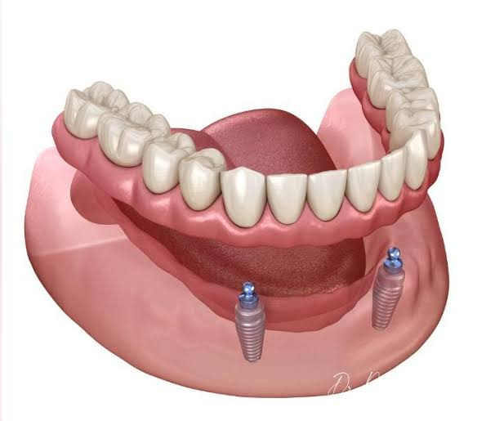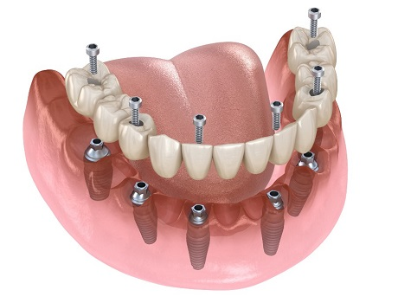
All on 2 All on 6

How are All on 4 Dental Implants placed? (H2)

Conventional All on 4 with slanted implants

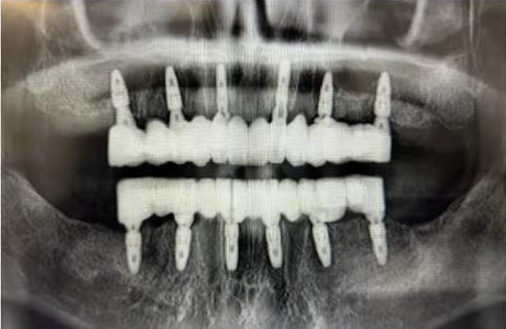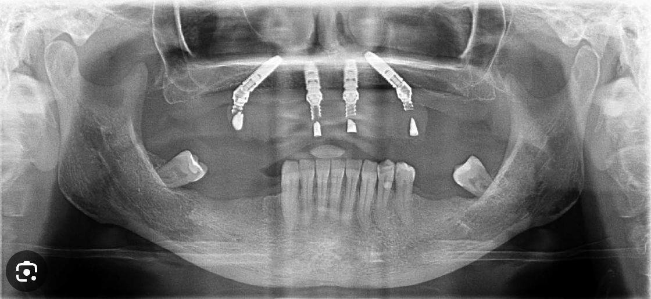

Zygomatic Implants

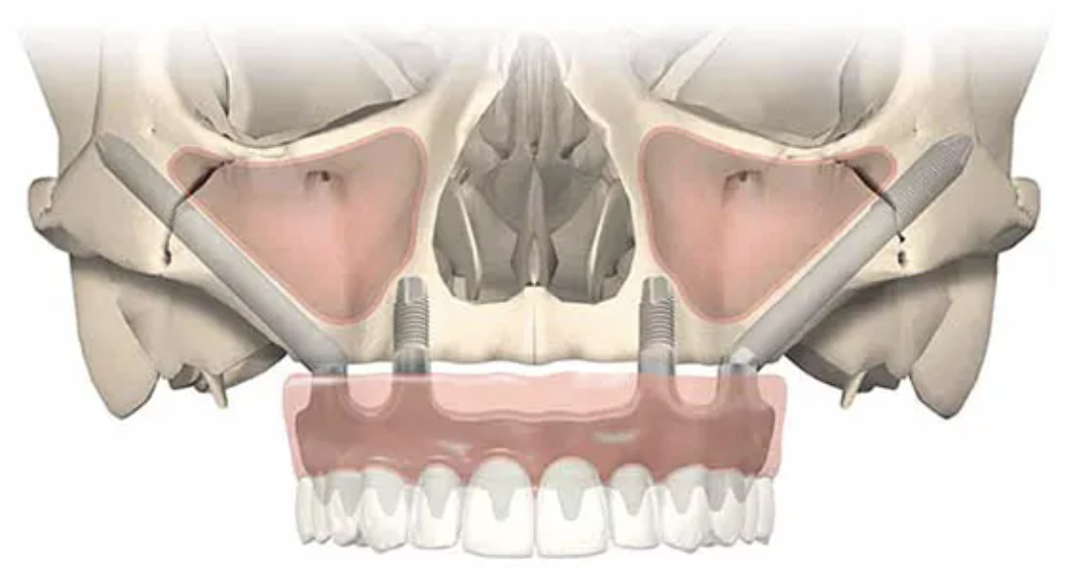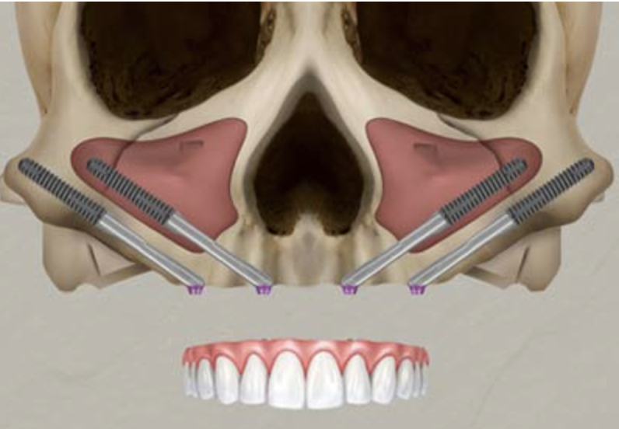

Subperiosteal Implants

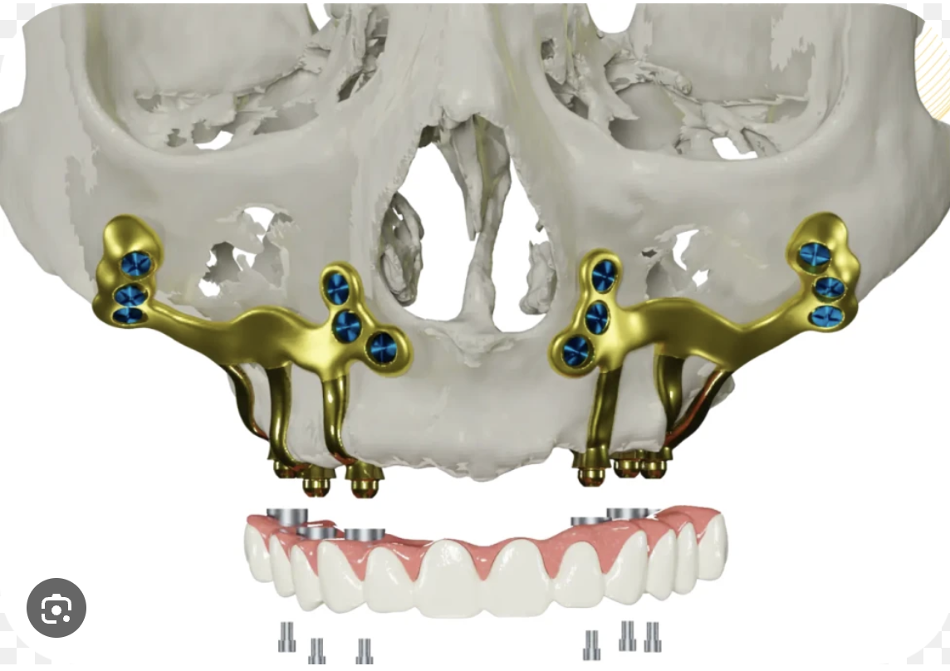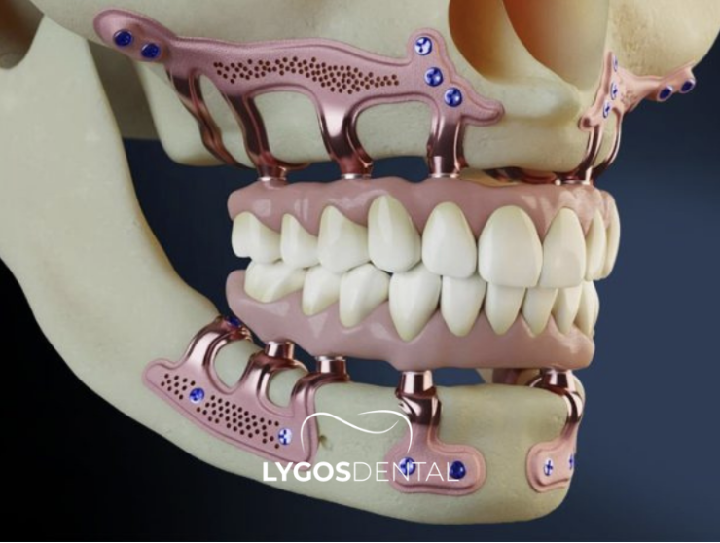

The Dental Implants used at Smile Concepts (H2)
We are not a single-brand clinic. Smile Concepts works with several of the world's leading implant systems, including Neoss, DIO, Nobel Biocare and Straumann, among others, and our dentists have trained on and worked with most major systems.
Why does this matter to you? Because your jaw is unique. A clinic tied to one brand has to make your anatomy fit their implant. We choose the implant system that best fits your bone, your bite and your long-term outcome, not the other way around. This is brand-agnostic, anatomy-first implant dentistry.
We also assess revision cases from other clinics and overseas. When a full arch treatment done elsewhere hasn't worked out, correcting it takes broad experience across different implant systems and complex bone situations. That is exactly the experience our team has built.
Assessment is needed before we can confirm whether existing implants or the bridge can be retained.

Our All on 4 Technology (H2)
- 3D CBCT imaging: a full three-dimensional scan of your jaw so your implants are planned around your real anatomy, nerves and available bone before surgery begins.
- 4th generation digital guided implant technology: digital planning translated into precise, guided placement for predictable positioning across whichever implant system suits your case.
- Laser dentistry: used to support minimally invasive treatment and comfortable healing.

All on 4 or All on X with Bone Loss? (H2)
Bone loss after tooth loss is common and does not automatically rule out the All on 4 dental implant treatment concept.
As shown in the above images, we can approach implant treatment in several ways.
Angled implants may help use available bone while avoiding nearby structures. Some patients still need grafting or another approach. [1–3]

Our 3D imaging shows us exactly what is available before we make any recommendations.

Some cases may require bone grafting.

Recovery, Aftercare & Ongoing Maintenance after All on 4 Implant Surgery (H2)
Recovery from All on 4 is usually easier than people expect. Most Smile Concepts patients return to their normal routine within a few days, while the implants fuse with the jawbone over the next three to six months. Here is what to expect at each stage.

The First Few Days After Surgery: What to Expect (H3)
Some swelling, mild bruising, and general tenderness in the days after surgery are all normal. These effects are temporary and usually start fading within the first week.
We'll go through your aftercare plan with you in detail, covering:
- How to manage swelling and discomfort
- What medication you'll need and how to take it
- Oral hygiene during the early healing period
- What you can eat, and what to avoid for now
- When you can get back to normal activity

Eating During Healing (H3)
During this period, the implants fuse with the jawbone, so we recommend a softer diet to avoid putting unnecessary pressure on them. We'll explain exactly what's appropriate to eat at each stage of recovery.

Long-Term Maintenance (H3)
All on 4 is designed as a long-term solution, but it still needs ongoing care to stay that way.
To help maintain the health of your implants and the surrounding tissue, we recommend:
- Daily brushing and cleaning around the bridge
- Following the oral hygiene instructions your clinician gives you
- Attending regular dental check-ups
- Booking in for professional implant maintenance and cleaning
- Letting us know promptly if anything feels off
With proper care, many patients go on to enjoy their All on 4 implants for years to come.

Prosthetics (Teeth)

Temporary Teeth and Final Teeth: What To Expect (H2)
Will you be without teeth during treatment? For most suitable patients, no.
A fixed temporary bridge may be fitted on the day of surgery or shortly afterwards if implant stability and other clinical factors allow. If immediate loading is unsuitable, your dentist will explain the alternative plan. Temporary teeth require a modified diet during healing. [1]

Once healing is complete, the final bridge is designed and fitted. We walk you through your material options at consultation, including the difference between acrylic and zirconia, so you can make a decision that actually makes sense for your budget and your priorities rather than just accepting whatever is standard.
It is worth understanding the difference between the two stages when you are comparing costs, because the materials and work involved are quite different.

Acrylic or Zirconia Teeth: Choosing Your Final Teeth (H2)
Your final fixed teeth come in two materials, and both are fitted in Phase Two once your implants have healed. Unlike the temporary teeth you leave with after surgery, these are built for long-term wear.
Here is how acrylic on titanium and zirconia compare, so you can choose the option that suits your bite, budget, and goals.
- Acrylic on titanium ($10,000): a lighter, reliable and more economical option. The teeth are acrylic bonded to a strong titanium bar, and the surface may need an occasional refresh or repair over the years.
- Zirconia ($14,000): offers high strength, excellent stain resistance and very natural aesthetics. Zirconia is milled from a single ceramic block, resists chipping and staining, and is the choice most patients make when longevity and aesthetics are the priority.
We walk you through both options at your consultation, with examples you can see and hold, so the decision fits your budget and your priorities.

Our 5-Step All on 4 and All on X Process (H2)

From first scan to final smile, one team handles every stage in house at Smile Concepts in Sydney.

Step 1: Consultation and Assessment (H3)
A full clinical examination with 3D CBCT imaging and a review of your medical history.
The scan gives us a detailed map of your jawbone, so we can plan implant placement precisely before we do anything.
We also talk through your goals and concerns at this appointment.

Step 2: Treatment Planning (H3)
We build a personalised treatment plan and walk through it with you in detail.
You will know exactly what is being done, what it costs, and what to expect at each stage before anything starts.

Step 3: Implant Placement (H3)
Most patients choose to have their implants placed under IV sedation for comfort.
Any remaining teeth that need removing are taken out at the same appointment.
In most suitable cases, a temporary set of teeth is fitted the same day.
The number of implants placed, usually four to six, follows your dentist's analysis of your scans, at no change to your quoted price.

Step 4: Healing and Integration (H3)
Over the following months, the implants fuse with the surrounding bone. We monitor progress through review appointments.
Your temporary teeth let you eat and speak normally throughout this phase.

Step 5: Final Restoration (H3)
Once healing is complete, your final bridge is designed and fitted.
We explain your material options, including the difference between acrylic and zirconia, at your consultation so you can make an informed decision.

All on 4 vs. Traditional Dentures: How Do They Compare? (H2)
While dentures remain a suitable option for some people, they are removable and may become loose over time as the jawbone changes. The most suitable option depends on your oral health, goals, and clinical assessment.
In our Sydney practice, one of the most common questions we hear from denture wearers is whether significant bone loss rules them out.

Feature | All On 4 | Traditional Dentures
Fixed in place | Yes | No
Removed for cleaning | No | Yes
Stability when eating | Higher | May vary
Denture adhesives required | Usually not | Often
Supported by implants | Yes | No
Designed as a fixed solution | Yes | No

Cost

Understanding All on 4 Dental Implants Cost in Sydney (H2)
A common issue we see when reviewing external All on 4 or All on X quotes is that the advertised fee includes temporary teeth but not the definitive bridge.
All on 4 cost at Smile Concepts ranges from $18,000 to $32,000 per arch in Sydney, quoted in two clear phases.
Phase one, at $18,000 per arch, covers your surgery and the fixed temporary teeth you leave with on the day of surgery or shortly afterwards.
Phase two is your final fixed teeth, at $10,000 for acrylic on titanium or $14,000 for zirconia. What drives your total is your materials, your anatomy and your choices, never the number of implants, because we don't charge per implant.
After your consultation, we provide a full written quote with itemised costs. There are no surprise fees added later. What we quote is what you pay.
What Affects the Cost | What It Means for You
Bridge material | Zirconia and acrylic have different costs, repair needs and material properties. The choice depends on your bite and bridge design.
Number of arches being treated | Treating the upper arch, lower arch, or both will change the total investment.
Extractions needed | Planned extractions are included in phase one as described; the written quote confirms the scope.
Sedation | If you prefer to be sedated during the procedure, this adds to the overall cost and is available at our clinic managed by trained sedationists.
Complexity of your case | Bone loss, previous implant history, or other clinical factors can affect the planning and surgical approach.
Number of implants | Our clinic quotes per arch rather than per implant; the written plan confirms the included implant number.

Your Investment: Transparent Two Phase Pricing (H2)
Your All on 4 or All on X treatment is quoted in two clear phases, the surgical phase and the final bridge phase, so nothing is hidden.

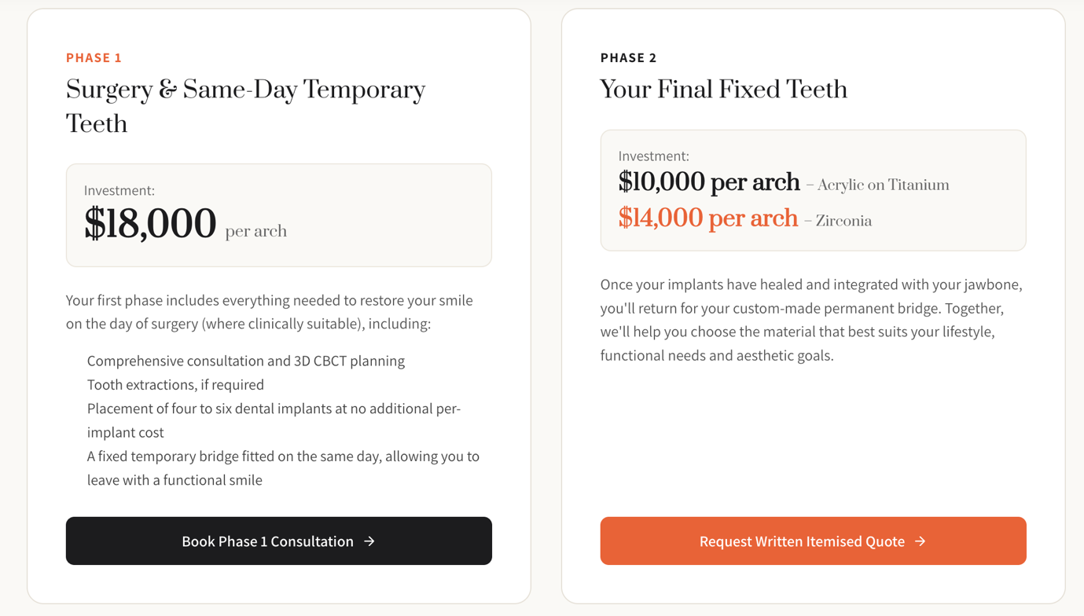

Sedation and bone grafting fees are not included in the phases above. They are quoted separately and only if you need them, and we will discuss both openly at your consultation before anything is decided.

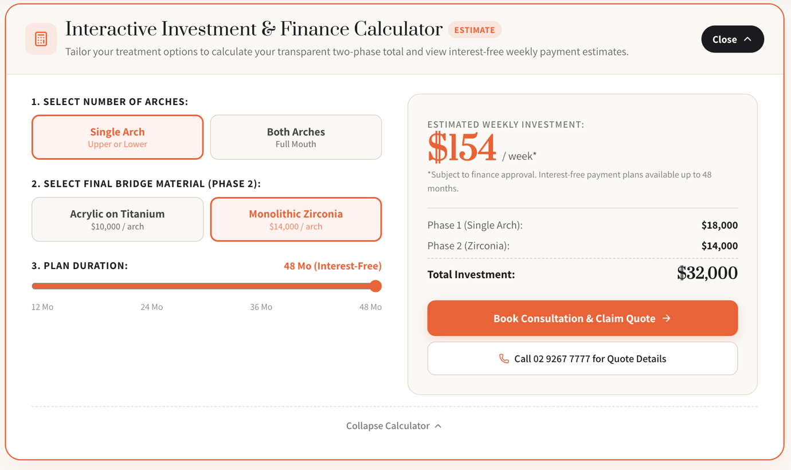

Is There A Cheaper Alternative to All on 4? (H2)
Yes. If fixed All on 4 teeth are outside your budget, Smile Concepts offers snap on implant dentures, also called an implant overdenture or All on 2, from $12,000 per arch. It is a removable denture that clips onto implants, giving far more stability than a conventional denture at a lower cost than fixed teeth.

What Are Snap-on Implant Dentures or Clip-on Implant Dentures (All On 2)? (H3)
Unlike a conventional denture that rests on your gums and relies on suction or adhesive, a snap on implant denture is a custom made removable denture that clips securely onto dental implants placed in your jaw. In the lower jaw this usually means two implants, which is why it is often called All on 2. The upper jaw usually needs four implants because the bone is softer.
- Much more secure: special locator attachments hold the denture in place while you eat, laugh and speak, greatly reducing the slipping, rubbing and sore spots common with conventional dentures.
- Removable for easy cleaning: you unclip it yourself for daily cleaning and at night.
- Less palate coverage: in the upper jaw, implant support often allows a slimmer denture that leaves more of the roof of your mouth uncovered, so food tastes better and the denture feels less bulky.
- A possible stepping stone: depending on your bone and implant positions, an implant denture can sometimes be upgraded to fixed All on 4 teeth later. Your dentist will tell you whether your implants could be reused.
- Worth knowing: the small clip inserts wear over time and are replaced periodically as part of routine maintenance.

All on 4 vs Snap On Implant Dentures at a Glance (H3)

 | All on 4 (All on X) | Snap on implant dentures
Fixed or removable | Fixed, only your dentist removes it | Removable, you unclip it daily
Number of implants | Usually 4 to 6 | Usually 2 lower, 4 upper
Price per arch | From $18,000 | From $12,000
Cleaning | Brush and clean under the bridge daily | Remove and clean daily
Feel when eating | Closest to natural teeth | Much more stable than a conventional denture
Palate coverage (upper) | None | Reduced

Suitability depends on your jawbone, oral health and which jaw is being treated. We walk you through both fixed and snap on options at your consultation so you can compare them side by side, and interest free payment plans are available for either.

Does Private Insurance or Medicare cover any of the costs of All on 4? (H2)
Private health insurance benefits depend on your policy, item numbers, waiting periods and annual or lifetime limits.

Ask your insurer for a written benefit estimate using your itemised quote. Medicare generally does not cover routine private dental implant treatment. [6]

Can I Use My Superannuation to Pay for All on 4 Treatment? (H2)
Possibly.
If dental treatment is needed to relieve chronic pain or a condition affecting your quality of life, you may be eligible to apply to the ATO for early release of superannuation on compassionate grounds.
The ATO assesses applications case by case against strict criteria, requires supporting reports from two practitioners and an itemised treatment plan, and recommends considering other payment options first.
Consider the tax and retirement savings implications and seek independent financial advice. [7]

We work with SuperCare to help patients through this process. Ask us about it at your consultation or learn more about SuperCare here.

Do We Offer Payment Plans for All on 4 Treatment? (H2)
Yes.
Interest-free payment plans are available up to 48 months and up to $30,000, based on eligibility, from around $90 per week (subject to eligibility, approval and terms).
Ask our team which option suits your circumstances, and we will include your payment options in your written quote.

Risks

What You Should Know About Risks Associated with All on 4 Dental Implants (H2)
All on 4 (All on X) has a strong clinical track record, but it is a surgical procedure, and every patient should understand the risks before proceeding. Any surgical or invasive procedure carries risks. Before proceeding, you should seek a second opinion from an appropriately qualified health practitioner.
- Healing varies: Overall health, blood supply, and adherence to post-operative instructions affect how well and how quickly implants integrate.
- Smoking is associated with higher implant failure risk and greater bone loss. Discuss stopping smoking and individual risk management with your treating team. [4]
- Medical history matters: Certain medications and conditions can affect healing, so we take a full history before proceeding.
- Maintenance is not optional: The bridge and implants need regular professional cleaning. Skipping maintenance appointments increases the risk of complications over time.
- Implant failure is possible: an implant may not integrate or may lose support later. Biological and mechanical complications can occur even after initial healing. [2–5]

All on 4 Revision and Failed Implant Treatment
We assess existing full arch implants and bridges placed at other clinics or overseas.

Problems may involve an implant that has failed, inflammation and bone loss around implants, a broken bridge or an uncomfortable bite. Bring previous records, scans and implant brand details if available.

Depending on the findings, treatment may involve repairing or replacing the bridge, treating disease, removing failed implants or planning further surgery.

Existing implants cannot always be reused, and you must check compatibility with replacement components.

Revision treatment is individually quoted after assessment.

Longevity

How Long Do All on 4 Implants and Bridges Last? (H2)
The implants in the jawbone and the bridge attached to them have different maintenance needs.

Long-term studies support the use of All on 4 in selected patients, but they also report biological and mechanical complications.

A bridge may need repair or replacement while its implants remain usable. No individual lifespan is guaranteed. [2,3]

Regular reviews assess the gums, bone support, bite, bridge and screws. Cleaning access, smoking, health and bite forces all influence ongoing care. Ask about likely maintenance and replacement costs before treatment. [4,5]

Meet Your Full Arch Implant Dentists (H2)
Your treatment at Smile Concepts is led by two experienced clinicians who plan and deliver every case in-house at our Sydney CBD practice.

Dr Manish Shah, BDS (Hons), MBBS, MMED (Sleep Medicine), University of Sydney (H3)
Dr Manish Shah is a registered dentist and medical practitioner. He graduated in Dentistry with honours from the University of Sydney in 1998, completed his Medical Degree in 2005, and holds a Master of Medicine in Sleep Medicine. With more than 25 years in restorative and cosmetic dentistry, he brings a rare dual clinical perspective to full-arch implant surgery and prosthetics, with a focus on patient comfort.
AHPRA registration: DEN0001361239 (Dental) and MED0001361238 (Medical)

Dr Kinnar Shah, BDS, University of Glasgow (H3)
Dr Kinnar Shah completed his dental training in Glasgow in 2000 and has more than 25 years of experience in implant, cosmetic and full-mouth rehabilitation dentistry. He uses digitally guided implant techniques and trains other dentists in advanced implant and full-mouth rehabilitation.
AHPRA registration: DEN0001309395 (Dental)
Together, Dr Manish Shah and Dr Kinnar Shah have trained on and worked with most of the world's leading implant systems and regularly take on revision cases referred from other clinics and from overseas.

Why Patients Choose Smile Concepts (H2)
Choosing all on 4 procedure is a significant decision. Patients want experienced care, clear communication, and a treatment plan tailored to their needs.
- Over 25 Years of Experience: Dr Manish Shah and Dr Kinnar Shah each bring over 25 years of experience with a strong focus on complex restorative and implant cases.
- 3D Imaging and Digital Planning: CBCT imaging is standard on every all on 4 procedure we do. It gives us a detailed picture of your bone before anything happens, and we use guided surgical planning to improve precision.
- Everything Under One Roof: Consultation, imaging, surgery, temporary teeth, final restoration, and ongoing maintenance all happen here. One team that knows your case the whole way through.
- Experience With Complex Cases: Significant bone loss, years of denture wear, multiple failing teeth. We see these regularly and plan properly for them.
- Sedation Available: If the procedure makes you very anxious, sedation is available. You do not have to push through something that really stresses you out.
- Multiple Implant Systems: We work across leading systems including Neoss, DIO, Nobel Biocare, Straumann, and many other leading implant brands, and accept revision cases from other clinics and overseas.
- Flexible Ways to Pay: Interest-free payment plans up to 48 months and up to $30,000 (eligibility applies), plus guidance on superannuation access for eligible patients.

Trusted by Sydney Patients (H2)
Smile Concepts is an award winning Sydney CBD dental practice with 600+ Google reviews. Read what our patients say on Google.

Book an All on 4 Consultation in Sydney (H2)
If you are considering all on 4 dental implants (full arch) in Sydney, the first step is understanding your options.
Our team will assess your oral health, discuss your concerns, and explain the most appropriate treatment options for your individual circumstances.
Whether you are exploring alternatives to dentures or looking for a fixed solution for failing teeth, we are here to help you make an informed decision with clear advice and personalised care.

Complete My Smile (H3)

Teeth in a Day
Fixed temporary teeth fitted the same day as surgery, for suitable cases

Fast Recovery
Less discomfort, minimal bleeding, and quicker healing

Accurate & Precise
Advanced digital planning for predictable implant placement

From $90/Week*
Interest free plans up to 48 months and up to $30,000. *Based on eligibility; terms apply.

Trusted Experience
Sydney implant dentists, each with 25+ years of experience

Free Parking
Easy access in Sydney CBD with complimentary parking

Frequently Asked Questions (H2)

What is the difference between All on 4 and All on X? (H3)
There is no difference in the treatment. Both give you a full arch of fixed teeth on dental implants. “All on 4” is the well-known name, while “All on X” means the number of implants (the “X”) is tailored to you, usually four to six. At Smile Concepts, we plan each case to your anatomy and don't charge per implant.

Is All on 4 surgery painful? (H3)
Generally, the procedure itself is not painful.
Most patients choose sleep dentistry (IV sedation), so they stay completely relaxed throughout.
They typically report the discomfort afterwards is less than they expected and is well managed with prescribed pain relief and simple aftercare.

How long does recovery take? (H3)
Many patients return to light activities within a few days.
Most surgical recovery happens over 2 to 4 weeks
Full healing and integration of the implants with your jaw typically takes three to six months, during which you wear your fixed temporary teeth before your final bridge is fitted.

Can I get all on four implants if I have bone loss? (H3)
Possibly, yes.
Bone loss does not automatically rule you out. Angled implants may make use of available bone, but some people need grafting or a different approach. Suitability is determined with clinical examination and 3D imaging. [1–3]

Severe bone loss may require assessment for advanced options such as zygomatic or pterygoid implants. These have different risks and may require specialist referral.

Can I keep the temporary teeth and skip the final bridge? (H3)
Temporary teeth are intended for the healing phase and need a modified diet. They are adjustable as tissues change but are not a substitute for the planned definitive bridge. They are a short term solution and designed to last no longer than 6 to 12 months.

Once your implants have healed, we fit your final fixed teeth on a titanium base with acrylic or zirconia teeth on top, built to last. This is why every All on 4 plan at Smile Concepts includes both phases.

Can I really get teeth in a day? (H3)
When immediate loading is suitable, yes. Immediate loading depends on bone, implant stability, bite and health. We can place your implants and fit a fixed temporary bridge the same day or the next day, so you can leave with teeth.
Your final bridge is fitted after your implants have healed and integrated with the bone, usually within three to six months.

How much do All on 4 dental implants cost at Smile Concepts in Sydney? (H3)
At Smile Concepts, All on 4 or All on X is quoted in two phases.
Phase one, which includes your implants and the fixed temporary teeth you leave with on the day of surgery (where suitable), is $18,000 per arch.
Phase 2 includes your final fixed teeth: $10,000 for acrylic on titanium or $14,000 for zirconia on titanium or pure zirconia, so complete treatment ranges from $28,000 to $32,000 per arch.
We don't charge per implant, and you receive a written, itemised quote after your examination, photos and 3D CT scan.

What is included in the cost of All on 4 dental implants? (H3)
At Smile Concepts, phase one of your quote ($18,000 per arch) includes your consultation, 3D CBCT planning, any extractions, placement of your implants (usually four to six) and your same-day fixed temporary teeth.
Phase two covers your final fixed teeth in acrylic or zirconia.
Your care doesn’t stop at phase two. The same team that planned and placed your implants looks after you for the long term, with regular reviews, professional implant maintenance and cleaning, and prompt help if anything ever feels loose or uncomfortable. We’ll explain your recommended maintenance schedule and any ongoing costs at your consultation.
Sedation and bone grafting are quoted separately, and we confirm everything in a written, itemised quote.

How many implants will I need, and does it change the price? (H3)
Your dentist decides the number of implants, most commonly four to six (and sometimes eight), after analysing your X-rays and 3D CBCT scan.
It depends on your bone and what gives you the most stable result. Because we don't charge per implant, the number placed does not change your price. Your quote is driven by case complexity, not implant count.

Can I use my superannuation to pay for All on 4 or All on X? (H3)
Eligible patients may apply to the ATO for compassionate release of superannuation. We can provide treatment information and discuss application support, but the ATO determines approval.

Confirm current supporting report requirements with the ATO and consider independent financial advice before applying. [7]

We partner with SuperCare who can help you manage the application process with the ATO.

Is there a cheaper alternative to All on 4? (H3)
Yes. Snap on implant dentures, also called an implant overdenture or All on 2, start from $12,000 per arch at Smile Concepts. The denture clips onto two to four implants and is removed for cleaning, so it costs less than fixed All on 4 teeth while being far more stable than a conventional denture.

How long do All on 4 dental implants last? (H3)
Dental implants and full-arch bridges are intended as long-term treatment, but no lifespan is guaranteed.

Implants, components and bridge materials can require maintenance, repair or replacement.
Longevity depends on oral hygiene, regular checkups, smoking, overall health, bite forces, and other individual factors.

We'll show you exactly how to care for your new teeth.

Is All on 4 better than dentures? (H3)
They solve the same problem in different ways.
All on 4 gives you fixed teeth that stay in place, so you don't have to remove them daily, no adhesive, and more stability when eating.
Dentures remain a reasonable option for some patients.
The right choice depends on your oral health, your bone and your goals, which is what your assessment confirms.

Can smokers have all on 4 dental implants? (H3)
Smoking is associated with increased implant failure risk and bone loss. Suitability is assessed individually; stopping smoking is an important risk reduction step. [4]

Nicotine reduces blood flow to the bone and gums, which slows healing and raises the risk of implant failure. We assess smokers individually, discuss the risks at consultation, and can talk through ways to reduce risk around the time of surgery.

A successful early result does not remove the longer-term risks associated with smoking.

How do I clean all on four dental implants? (H3)
Brush twice daily and clean beneath the bridge with the aids recommended for your design, such as suitable interdental brushes or floss.

A water flosser may be an adjunct.

Attend regular professional reviews so inflammation and mechanical problems can be detected early. [5]

What happens if my remaining teeth are failing? (H3)
That is one of the most common starting points for All on 4. During your assessment, we look at whether your remaining teeth can be saved or whether replacing the full arch is the more predictable long-term option.
If extractions are needed, they are done at the same appointment as your implant placement, and they are included in your phase one fee.

What if my Bridge breaks or an Implant fails? (H3)
Contact us promptly if the bridge becomes loose, breaks or causes pain.

Avoid chewing on the affected area and do not attempt a repair yourself.

The cause must be assessed before deciding whether repair, replacement or further implant treatment is appropriate.

Important Information About Your Treatment (H2)
All on 4 involves dental implant surgery. Any surgical or invasive procedure carries risks. Before proceeding, you should seek a second opinion from an appropriately qualified health practitioner.
Individual results vary and are not guaranteed. All on 4 may not be suitable for everyone, and suitability is confirmed only after a full clinical assessment and 3D imaging. Full treatment typically takes three to six months from implant placement to your final fixed bridge.
Prices shown are starting ‘from’ prices, are current at the time of publication and may change. Your final fee depends on your individual assessment, treatment requirements and material selections.
Your Smile Concepts dentists are registered with the Australian Health Practitioner Regulation Agency (AHPRA): Dr Manish Shah, AHPRA Reg DEN0001361239 (Dental) and MED0001361238 (Medical), and Dr Kinnar Shah, AHPRA Reg DEN0001309395.

Clinical Evidence and Patient Information Sources

[1] ITI. Loading Protocols for Fixed Prostheses in Edentulous Jaws. 2013 consensus.
https://academy.iti.org/academy/consensus-database/consensus-statement/-/consensus/loading-protocols-for-fixed-prostheses-in-edentulous-jaws/1313

[2] Maló P et al. All on 4 mandibular rehabilitation with 10 to 18 years of follow-up. Clinical Implant Dentistry and Related Research. 2019;21:565–577.
https://pubmed.ncbi.nlm.nih.gov/30924309/

[3] Maló P et al. All on 4 maxillary rehabilitation with 5 to 13 years of follow-up. Clinical Implant Dentistry and Related Research. 2019;21:538–549.
https://pubmed.ncbi.nlm.nih.gov/30924250/

[4] Mustapha AD, Salame Z, Chrcanovic BR. Smoking and Dental Implants: A Systematic Review and Meta-Analysis. Medicina. 2022;58:39.
https://pubmed.ncbi.nlm.nih.gov/35056347/

[5] Herrera D et al. Prevention and treatment of peri-implant diseases: EFP S3 clinical practice guideline. 2023.
https://pubmed.ncbi.nlm.nih.gov/37271498/

[6] Services Australia. Health care and Medicare.
https://www.servicesaustralia.gov.au/health-care-and-medicare?context=60092

[7] Australian Taxation Office. Access on compassionate grounds.
https://www.ato.gov.au/individuals-and-families/super-for-individuals-and-families/super/withdrawing-and-using-your-super/early-access-to-super/access-on-compassionate-grounds

Clinically reviewed by Dr Manish Shah, BDS (Hons), MBBS, MMED (Sleep Medicine), University of Sydney), AHPRA registration: DEN0001361239 (Dental) and MED0001361238 (Medical). Last reviewed: 15th October 2026.

